1.Write a C++ program to create a class called COMPLEX and implement the following overloading functions ADD that return a COMPLEX number.

i. ADD (a, s2) – where a is an integer (real part) and s2 is a complex number.

ii. ADD (s1, s2) – where s1 and s2 are complex numbers.

#include <iostream>

using namespace std;

class Complex

{

private:

int x,y;

public:

Complex(int x_=0,int y_=0): x(x_), y(y_){}

void get();

Complex add(int a, Complex s2);

Complex add(Complex s1, Complex s2);

void print();

};

void Complex::get()

{

cout<<"Enter the real part and imaginary part of a Complex number : ";

cin>>x>>y;

}

Complex Complex::add(int a, Complex s2)

{

Complex c(s2.x + a, s2.y);

return c;

}

Complex Complex::add(Complex s1, Complex s2)

{

Complex c(s1.x + s2.x, s1.y + s2.y);

return c;

}

void Complex::print()

{

cout<<x<<" + i"<<y<<endl;

}

int main()

{

Complex c1;

c1.get();

int a;

cout<<"Enter a value to add it the real part : ";

cin>>a;

Complex c2 = c1.add(a, c1);

cout<<"The Complex number after adding the real part is : ";

c2.print();

Complex c3 = c1.add(c1, c2);

cout<<"Addition of two Complex numbers : "<<endl;

cout<<" ";

c1.print();

cout<<" + ";

c2.print();

cout<<" = ";

c3.print();

return 0;

}

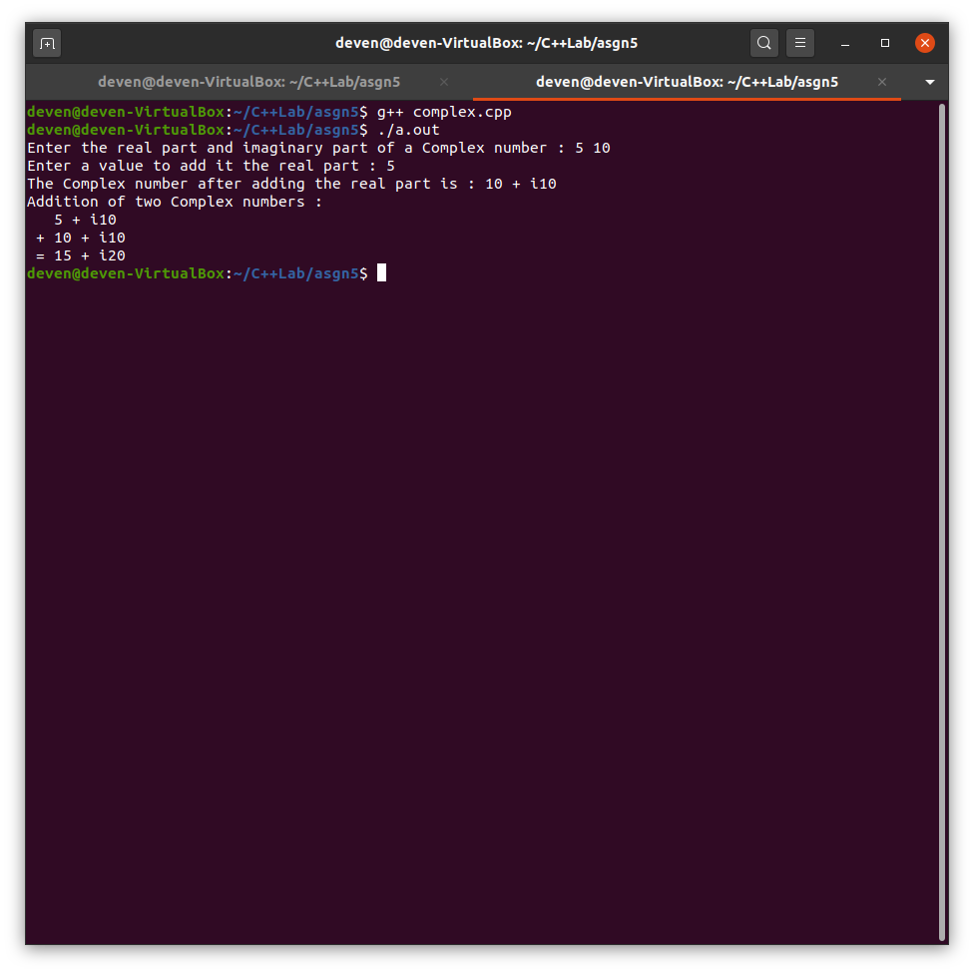

2. Write a C++ program to create a struct Distance with feet and inches. Implement the following overloading functions display

i. display(Dist d) - d is an object of Distance

ii. display(Float f) - f is an input from the user

#include <iostream>

using namespace std;

struct distance

{

float feet,inches;

};

typedef struct distance Distance;

void display(Distance d)

{

cout<<"Feet : "<<d.feet<<endl;

cout<<"Inches : "<<d.inches<<endl;

}

void display(float f)

{

cout<<"Entered value : "<<f<<endl;

}

int main()

{

Distance d={5,10};

display(d);

float f;

cout<<"Enter a float value : ";

cin>>f;

display(f);

return 0;

}

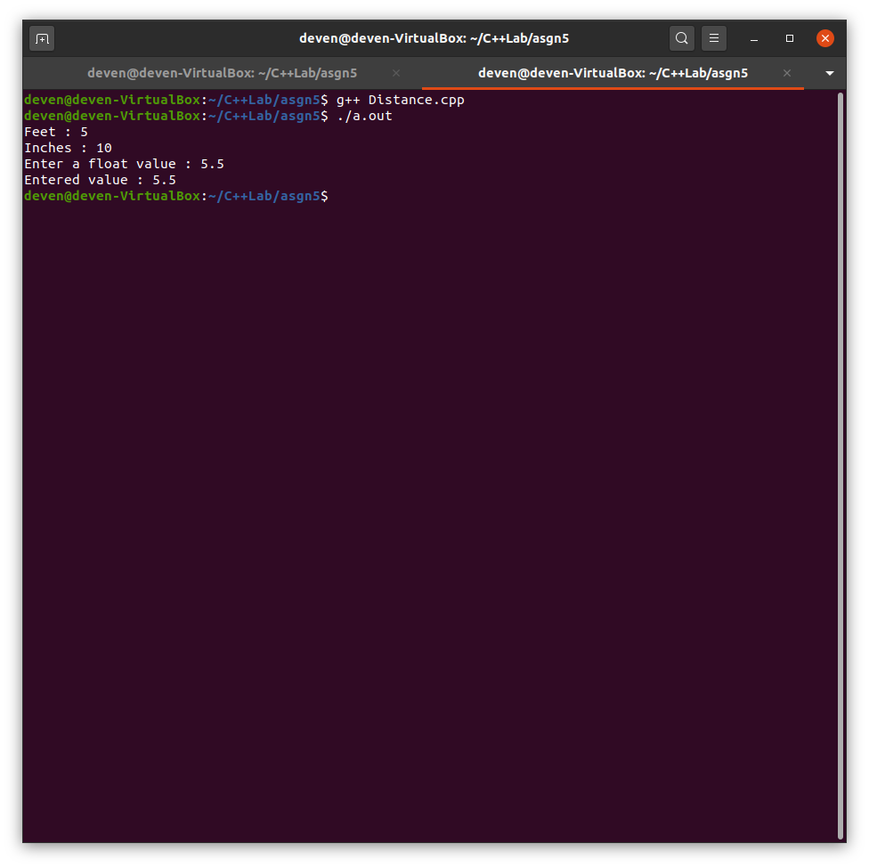

3. Create a namespace student with studentID and name, use a .h file to place this namespace. Display the student details from another file (Student.cpp)

//student.h

using namespace std;//for string , std::string name;

namespace student

{

int id;

string name;

}

//student.cpp

#include <iostream>

#include "student.h"

using namespace std;

using student::id;

using student::name;

int main()

{

cout<<"Enter student id and name : ";

cin>>id>>name;

cout<<"Student id : "<<id<<endl;

cout<<"Student name : "<<name<<endl;

return 0;

}

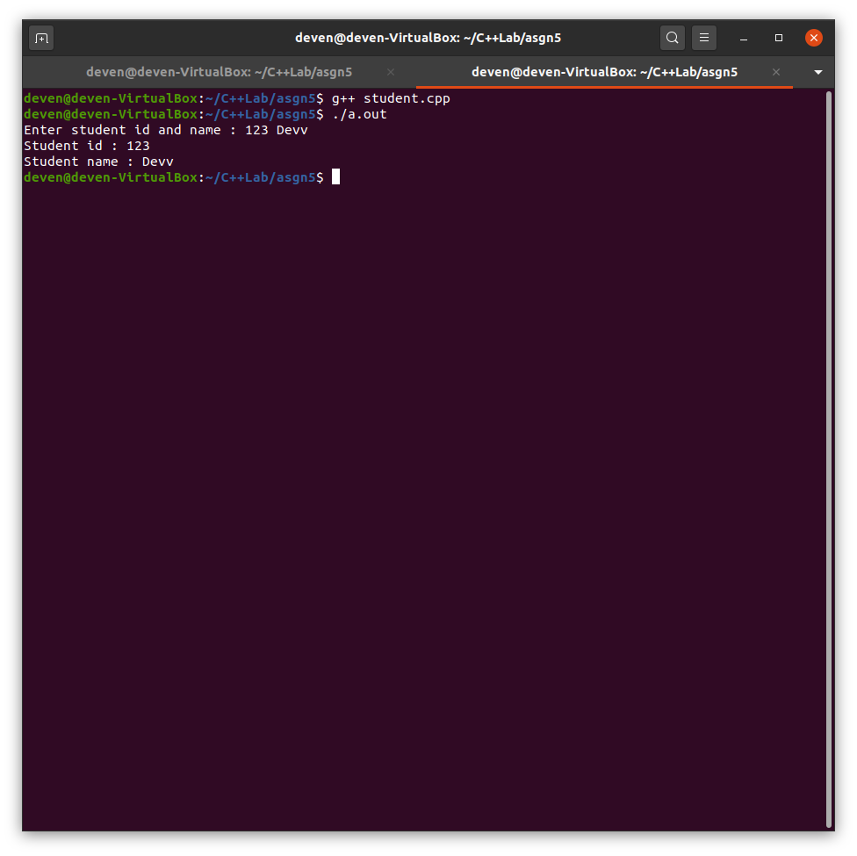

4. Illustrate nesting of namespaces and :: operators suitably.

#include <iostream>

using namespace std;

namespace student

{

int id = 500;

string name = "Deven";

namespace marks

{

int subject1 = 50;

int subject2 = 60;

int subject3 = 70;

}

}

int main()

{

cout<<"Student id : "<<student::id<<endl;

cout<<"Student name : "<<student::name<<endl;

cout<<"Student marks : "<<endl;

cout<<"Subject 1 = "<<student::marks::subject1<<endl;

cout<<"Subject 2 = "<<student::marks::subject2<<endl;

cout<<"Subject 3 = "<<student::marks::subject3<<endl;

return 0;

}

